Solve the given problems and show your complete solution (3 points each).

1. When $x^{4}+x^{3}-Px^{2}-4x+R$ is divided by $x-1,$ the remainder is 12. When divided by $x-2,$ the remainder is 0. Find $R$ and $P.$

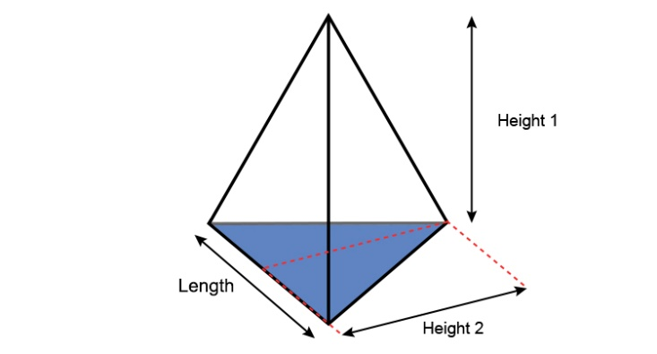

1. Find the height of a triangular-based pyramid, including the length and altitude of the base if the volume of the pyramid is $32$ cubic feet and the length of the base is 4 more than the height and the altitude is 2 less than twice the height.

Altitude

1. A ball was thrown upward with initial velocity of $25m/s$ from the ground. It the acceleration of gravity is $10m/s^{2}$,
2. what is the maximum height?
3. How long will it take the ball to reach the ground?
4. A class trip with a fixed cost of $\$6000$ will be evenly divided to the number of attendees. If there had been 10 more attendees, the cost per attendee would be $\$30$ less. How many joined the trip?